OG Web.site Unit 4 Assessment 6 Evidence Collection
Rob Johnston | OG Web.site evidence collection
Learner | Rob Johnston
Brand / document style | OG Web.site
Qualification | TQUK Level 3 Certificate in AI Programming with Python
Unit | Unit 4 - Linear Algebra Essentials for Deep Learning
Assessment | Pre-trained Networks, GPU-aware Training, Image Processing and Batching
Criteria covered: 3.3, 4.1, 4.2, 4.3, 4.4, 4.5, 4.6, 4.7
All visuals in this document are actual output files generated by the Python project scripts in this assessment folder.
Reference | Screenshot / output | Annotation
4.3, 4.4, 4.5 Image processing, normalisation and augmentation | 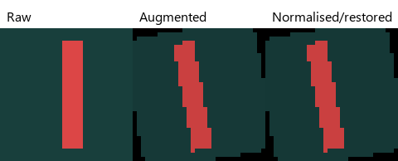 | Shows raw, augmented and normalised/restored image-processing output generated by the project script.
4.6 Data loading and batching | See project files listed in annotation. | The summary JSON records train_batches=12, validation_batches=3, test_batches=3 and batch_size=32.
4.1, 4.2, 4.7 Pre-trained network, GPU-aware script and checkpoints | 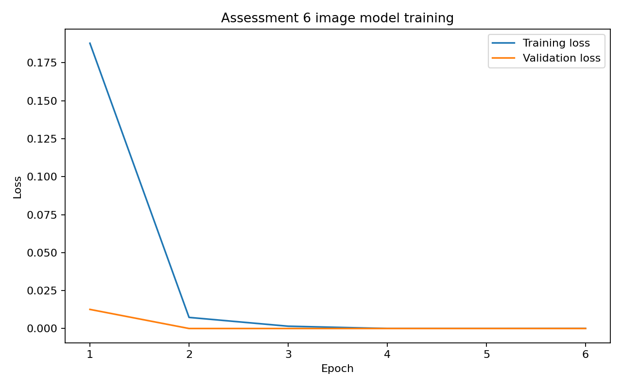 | The script pre-trains TinyFeatureExtractor, loads it into the target classifier, uses cuda if available, and saves/loads checkpoint files.
3.3 Inference |  | The trained model was loaded and used for image inference. Expected shape: diagonal. Predicted shape: diagonal.
Test result | 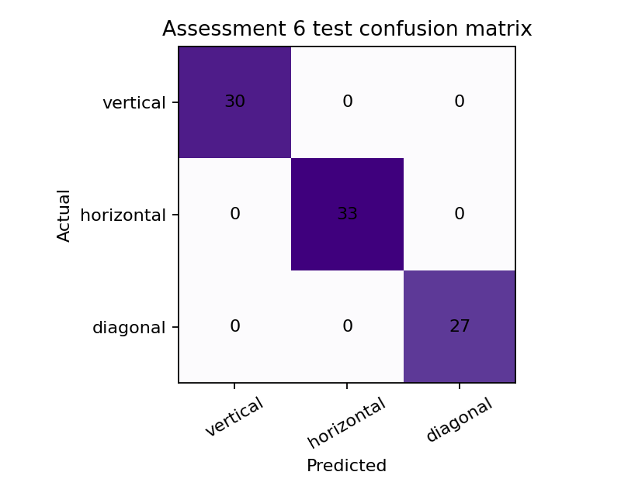 | The confusion matrix records the held-back test-set predictions. Test accuracy: 100.00%.

